**BANK LOAN REPORT**

1. **KPI’S**
2. **Total Loan Applications:**

select count(id) as Total_Loan_Applications

from bank_loan_data;



1. **MTD Loan Applications:**

select count(id) as Total_Loan_Applications

from bank_loan_data

where month(issue_date) = 12;



1. **PMTD Loan Applications:**

select count(id) as Total_Loan_Applications

from bank_loan_data

where month(issue_date) = 11;



1. **Total Funded Amount:**

select sum(loan_amount) as Total_Funded_Amount

from bank_loan_data



1. **MTD Total Funded Amount:**

select sum(loan_amount) as Total_Funded_Amount

from bank_loan_data

where month(issue_date) = 12



1. **PMTD Total Funded Amount:**

select sum(loan_amount) as Total_Funded_Amount

from bank_loan_data

where month(issue_date) = 12



1. **Total Amount Received:**

select sum(total_payment) as Total_Amount_Received

from bank_loan_data



1. **MTD Total Amount Received:**

select sum(total_payment) as Total_Amount_Received

from bank_loan_data

where month(issue_date) = 12



1. **PMTD Total Amount Received:**

select sum(total_payment) as Total_Amount_Received

from bank_loan_data

where month(issue_date) = 11



1. **Average Interest Rate:**

select avg(int_rate)*100 as Avg_Interest_Rate

from bank_loan_data



1. **MTD Average Interest Rate:**

select avg(int_rate)*100 as Avg_Interest_Rate

from bank_loan_data

where month(issue_date) = 12



1. **PMTD Average Interest Rate:**

select avg(int_rate)*100 as Avg_Interest_Rate

from bank_loan_data

where month(issue_date) = 11



1. **Avg DTI:**

select avg(dti)*100 as Avg_DTI

from bank_loan_data



1. **MTD Avg DTI:**

select avg(dti)*100 as Avg_DTI

from bank_loan_data

where month(issue_date) = 12



1. **PMTD Avg DTI:**

select avg(dti)*100 as Avg_DTI

from bank_loan_data

where month(issue_date) = 11



**GOOD LOAN ISSUED**

1. **Good Loan Percentage:**

select

(count(case when loan_status = 'Fully Paid' or loan_status = 'Current'

then id end)*100 / count(id)) as Good_Loan_Percentage

from bank_loan_data



1. **Good Loan Applications:**

select

count(id) as Good_Loan_Applications

from bank_loan_data

where loan_status in ('Fully Paid','Current')



1. **Good Loan Funded Amount:**

select

sum(loan_amount) as Good_Loan_Funded_Amount

from bank_loan_data

where loan_status in ('Fully Paid','Current')



1. **Good Loan Amount Received:**

select

sum(total_payment) as Good_Loan_Amount_Received

from bank_loan_data

where loan_status in ('Fully Paid','Current')



**BAD LOAN ISSUED**

1. **Bad Loan Percentage:**

select

(count(case when loan_status = 'Charged Off'

then id end)*100 / count(id)) as Bad_Loan_Percentage

from bank_loan_data



1. **Bad Loan Applications:**

select

count(id) as Bad_Loan_Applications

from bank_loan_data

where loan_status = 'Charged Off'



1. **Bad Loan Funded Amount:**

select

sum(loan_amount) as Bad_Loan_Funded_Amount

from bank_loan_data

where loan_status = 'Charged Off'



1. **Bad Loan Amount Received:**

select

sum(total_payment) as Bad_Loan_Amount_Received

from bank_loan_data

where loan_status = 'Charged Off'



**LOAN STATUS**

select

loan_status,

count(id) as Loan_Applications,

sum(loan_amount) as Total_Funded_Amount,

sum(total_payment) as Total_Amount_Received,

avg(int_rate)*100 as Interest_Rate,

avg(dti)*100 as DTI

from bank_loan_data

group by loan_status

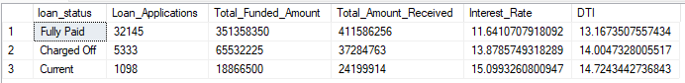

**MTD LOAN STATUS**

select

loan_status,

count(id) as Loan_Applications,

sum(loan_amount) as MTD_Total_Funded_Amount,

sum(total_payment) as MTD_Total_Amount_Received

from bank_loan_data

where month(issue_date) = 12

group by loan_status

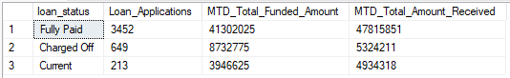

1. **BANK LOAN REPORT**

select month(issue_date) as Month_Number,

datename(month, issue_date) as Month_Name,

count(id) as Total_Loan_Applications,

sum(loan_amount) as Total_Funded_Amount,

sum(total_payment) as Total_Amount_Received

from bank_loan_data

group by month(issue_date),

datename(month,issue_date)

order by month(issue_date)

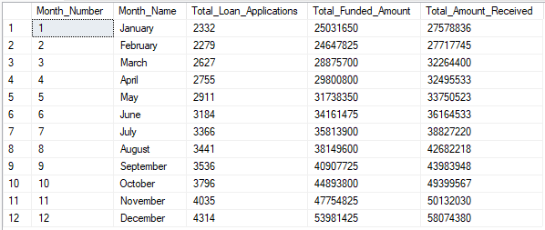

1. **STATE**

select address_state as State,

count(id) as Total_Loan_Applications,

sum(loan_amount) as Total_Funded_Amount,

sum(total_payment) as Total_Amount_Received

from bank_loan_data

group by address_state

order by address_state

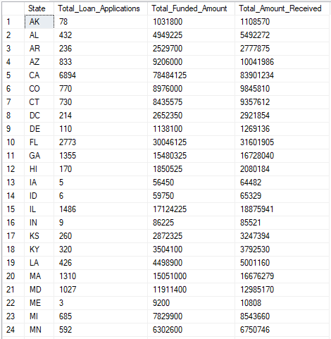

1. **TERM**

select term as Term,

count(id) as Total_Loan_Applications,

sum(loan_amount) as Total_Funded_Amount,

sum(total_payment) as Total_Amount_Received

from bank_loan_data

group by term

order by term

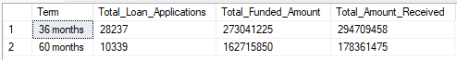

1. **EMPLOYEE LENGTH**

select emp_length as Employee_Length,

count(id) as Total_Loan_Applications,

sum(loan_amount) as Total_Funded_Amount,

sum(total_payment) as Total_Amount_Received

from bank_loan_data

group by emp_length

order by emp_length

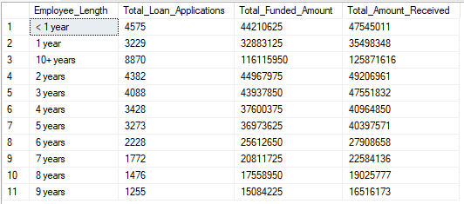

1. **PURPOSE**

select purpose as Purpose,

count(id) as Total_Loan_Applications,

sum(loan_amount) as Total_Funded_Amount,

sum(total_payment) as Total_Amount_Received

from bank_loan_data

group by purpose

order by purpose

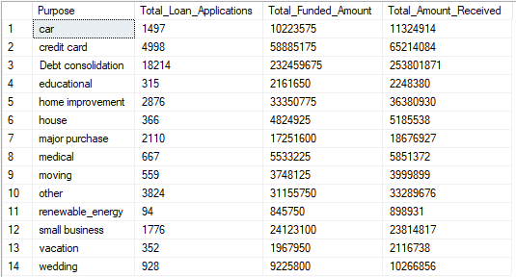

1. **HOME OWNERSHIP**

select home_ownership as Home_Ownership,

count(id) as Total_Loan_Applications,

sum(loan_amount) as Total_Funded_Amount,

sum(total_payment) as Total_Amount_Received

from bank_loan_data

group by home_ownership

order by home_ownership

